[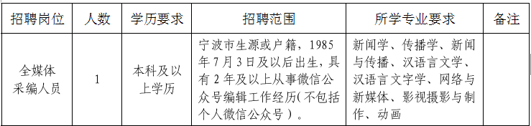](http://www.nbyz.gov.cn/picture/0/08c3e8e2fca64a2a82cb05751a0d70c2.png)