[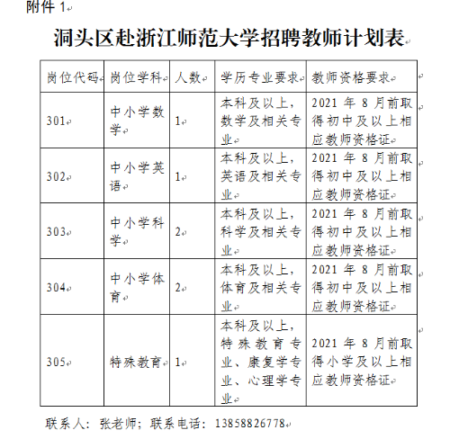](http://www.dongtou.gov.cn/picture/0/bee43e7949914245ba0d87ab604c6988.png)