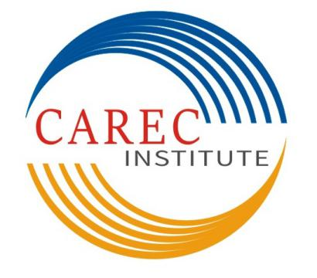

JobTitle: Senior Officer Strategic Planning
CAREC Institute
Terms of Reference

Central Asia Regional Economic Cooperation (CAREC) Institute has established as a knowledge institution for implementing the CAREC Program. The mission of the CAREC Institute (CI) is to enhance the quality and effectiveness of the CAREC Program by providing evidence based research, capacity building services and networking with research institutions. CI will need to support the CAREC Program’s strategic goals more directly and effectively in all aspects of its knowledge program including working more closely with CAREC sector coordinating committees, and being strategic and practical. CI takes an integrated approach to implement its strategic knowledge framework of knowledge generation, knowledge services and knowledge management. CI, being a results-oriented institution, its regional knowledge programs are designed and implemented through closer partnerships, and extensive networking and more collaboration with specialized agencies and institutions.
CI, located in Urumqi, Xinjiang Uygur Autonomous Region, People’s Republic of China (PRC), invites applications for Senior Officer Strategic Planning, an international professional staff position. Under the guidance of the Head of Strategic Planning Unit, he/she will promote and contribute to the strategic planning through policy foresight and strategy interventions.

Functions and Responsibilities:
- Support Head of Strategic Planning Unit in developing institution-wide strategic and business plans;
- Develop policy suggestions for regional economic cooperation and strategies in consultation with CI’s member countries;
- Conduct strategic and policy analysis on regional and national economic development in collaboration with relevant institutions in CI’s member countries;
- Actively participate in promoting cooperation and partnership with other institutions;
- Provide support in developing operational policies, procedures, and guidelines relevant to CI operations;
- Undertake monitoring and evaluation vis-à-vis agreed organizational objectives, draw lessons and report to management and share them with rest of the management;
- Prepare proposals on various institute-wide issues such as annual and medium-term work plans and major operational opportunities and challenges;
- Participate in developing a network of institutions in the CAREC region, as well as outside, that could collaborate in delivering and financing CI’s work program;
- Preparing and organizing regional policy and strategic workshops and seminars in consultation with CI’s research and training unit; and
- Any other relevant duties that may be assigned based on business needs.

Qualifications and Selection Criteria:
- Suitability to undertake the responsibilities mentioned above. Capable to work in a team of highly professional and technical international staff as well as local staff.
- A university degree in economics, business administration or related fields; preferably at post-graduate level or its equivalent.
- At least 10 years of relevant professional experience with demonstrated independence of thinking, team management and building, high-level of professional integrity, and strong analytical skills, and earned respect of professional peers.
- Strong academic research capabilities and analytical skills on policy and strategic issues related to energy, transport, trade and relevant sectors of CI operations.
- Experience and interest in strategic planning, good at policy formulation and coordination with development partners.
- As a supervisory-level international staff, the position requires a strong global view with preferably international and regional experience.
- Ability to interact and communicate effectively across organizational boundaries, with Management teams, and other international and local staff members.
- High proficiency in English, both oral and written communication is required.
- Applicants must be nationals of CAREC member countries, and candidates will be considered based on merit and suitability by considering position requirements and overall qualifications.

Immediate Reporting Relationships:
- Senior Officer Strategic Planning reports to the Head of Strategic Planning Unit.

Other Information:
- This is a 3-year fixed term appointment with possible extension.
- CI offers an internationally competitive compensation package in US dollars.

Application Procedure:
- The applications should be emailed to Ms. Nana (carecinstitute@163.com) by 7:00 p.m., Beijing time, Monday, 14 May 2018. CI is an equal opportunity employer and women are encouraged to apply. Only short-listed applicants will be contacted.
- The candidates are required to certify that all information provided on any employment application form, resume or CV is complete, true and accurate to the best of his/her knowledge. He/ She understands that information may be verified, and any misrepresentation of facts may be considered cause for dismissal regardless of when discovered by the CAREC Institute.

Eleven CAREC member countries include Afghanistan, Azerbaijan, People’s Republic of China (PRC), Georgia, Kazakhstan, Kyrgyz Republic, Mongolia, Pakistan, Tajikistan, Turkmenistan, and Uzbekistan.

