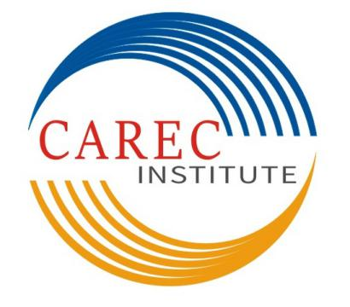

Job Title: Senior HR & Finance Officer
CAREC Institute

Terms of Reference

Central Asia Regional Economic Cooperation (CAREC) Institute has established as a knowledge institution for implementing the CAREC Program. The mission of the CAREC Institute (CI) is to enhance the quality and effectiveness of the CAREC Program by providing evidence based research, capacity building services and networking with research institutions. CI will need to support the CAREC Program’s strategic goals more directly and effectively in all aspects of its knowledge program including working more closely with CAREC sector coordinating committees, and being strategic and practical. CI takes an integrated approach to implement its strategic knowledge framework of knowledge generation, knowledge services and knowledge management. CI, being a results-oriented institution, its regional knowledge programs are designed and implemented through closer partnerships, and extensive networking and more collaboration with specialized agencies and institutions.
CI, located in Urumqi, Xinjiang Uygur Autonomous Region, People’s Republic of China (PRC), invites applications for Senior HR & Finance Officer, an international professional staff position. Under the guidance of the Head of Human Resources and Finance Unit, he/she will contribute to budget and expenditure management, and human resource management through financial control and HR interventions.

Functions and Responsibilities:
- Provide support to Head of HR & Finance Unit in preparing and implementing budget, including budget application and management procedures;
- Support in formulating the annual budget, consistent with CI’s work plan and operational requirements;
- Prepare budget utilization reports and establish a process of reallocating resources and re-prioritizing programs that allows delivery of quality results within available budget;
- Ensure compliance of financial procedures, regulations and accuracy of all expenditures before submission to Head of HR & Finance Unit and CI management for approval;
- Process all documents for approval and financial closure;
- Implement cost and expenditure monitoring system in support of budgetary planning and control measures;
- Prepare working papers and organize activities related to audit;
- Undertake monitoring and evaluation vis-à-vis agreed organizational objectives, draw lessons and report to management and share them with rest of the management;
- Support units concerned in the formulation of financial policies, guidelines, Human Resource policies, administrative orders, and to ensure institute-wide consistency on implementing these policies, procedures and guidelines;
- Conduct internal training programs based on the staff needs in the field of human resources and finance;
- Support implementation of compensation and benefit system for CI; and
- Any other relevant duties that may be assigned based on institutional needs.

Qualifications and Selection Criteria:
- Suitability to undertake the responsibilities mentioned above. Capable to work in a team of highly professional and technical international staff as well as local staff.
- A university degree in economics, finance, accounting, business administration and other related fields; preferably at post-graduate level or its equivalent.
- At least 10 years of relevant professional experience with demonstrated independence of thinking, team management and building, high-level of professional integrity, and strong analytical skills, and earned respect of professional peers.
- As a supervisory-level international staff, the position requires a strong global view with preferably international and regional experience.
- Ability to interact and communicate effectively across organizational boundaries, with Management teams, and other international and local staff members.
- High proficiency in English, both oral and written communication is required.
- Applicants must be nationals of CAREC member countries, and candidates will be considered based on merit and suitability by considering position requirements and overall qualifications.

Immediate Reporting Relationships:
- Senior HR & Finance Officer reports to the Head of Human Resources and Finance Unit.

Other Information:
- This is a 3-year fixed term appointment with possible extension.
- CI offers an internationally competitive compensation package in US dollars.

Application Procedures:
- The applications should be emailed to Ms. Nana (carecinstitute@163.com) by 7:00 p.m., Beijing time, Monday, 14 May 2018. CI is an equal opportunity employer and women are encouraged to apply. Only short-listed applicants will be contacted.
- The candidates are required to certify that all information provided on any employment application form, resume or CV is complete, true and accurate to the best of his/her knowledge. He/ She understands that information may be verified, and any misrepresentation of facts may be considered cause for dismissal regardless of when discovered by the CAREC Institute.

Eleven CAREC member countries include Afghanistan, Azerbaijan, People’s Republic of China (PRC), Georgia, Kazakhstan, Kyrgyz Republic, Mongolia, Pakistan, Tajikistan, Turkmenistan, and Uzbekistan.

