[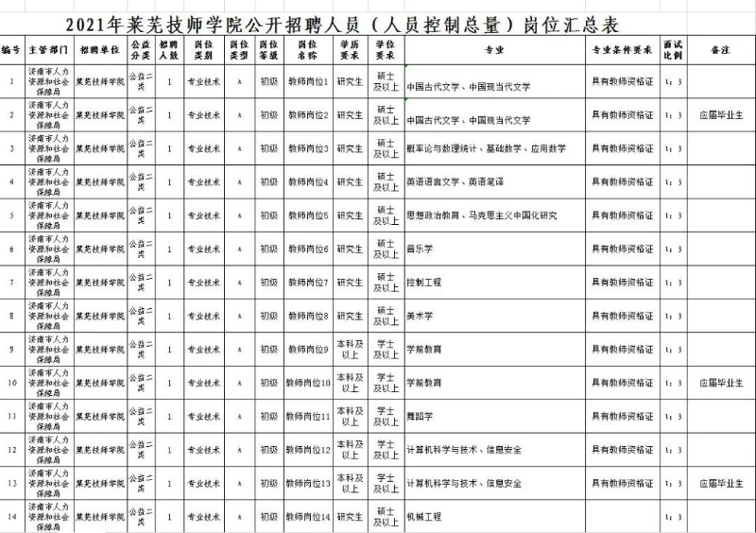](http://jnhrss.jinan.gov.cn/picture/0/fbbb46ddaf124aa0aa14c5b396409d7d.jpg)

[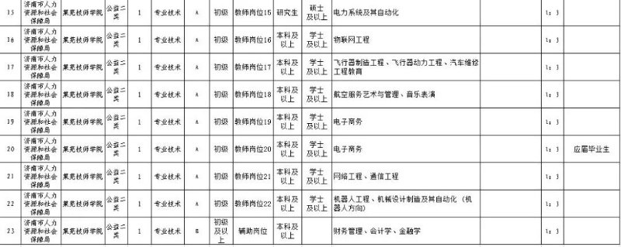](http://jnhrss.jinan.gov.cn/picture/0/ba9b681fc02b4aa2bf439f7c71eb58dc.jpg)