招聘计划及要求

[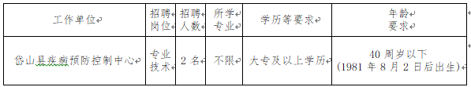](http://www.daishan.gov.cn/picture/0/ce8e7bff771a4335b380a1ea9cfe06b3.png)