[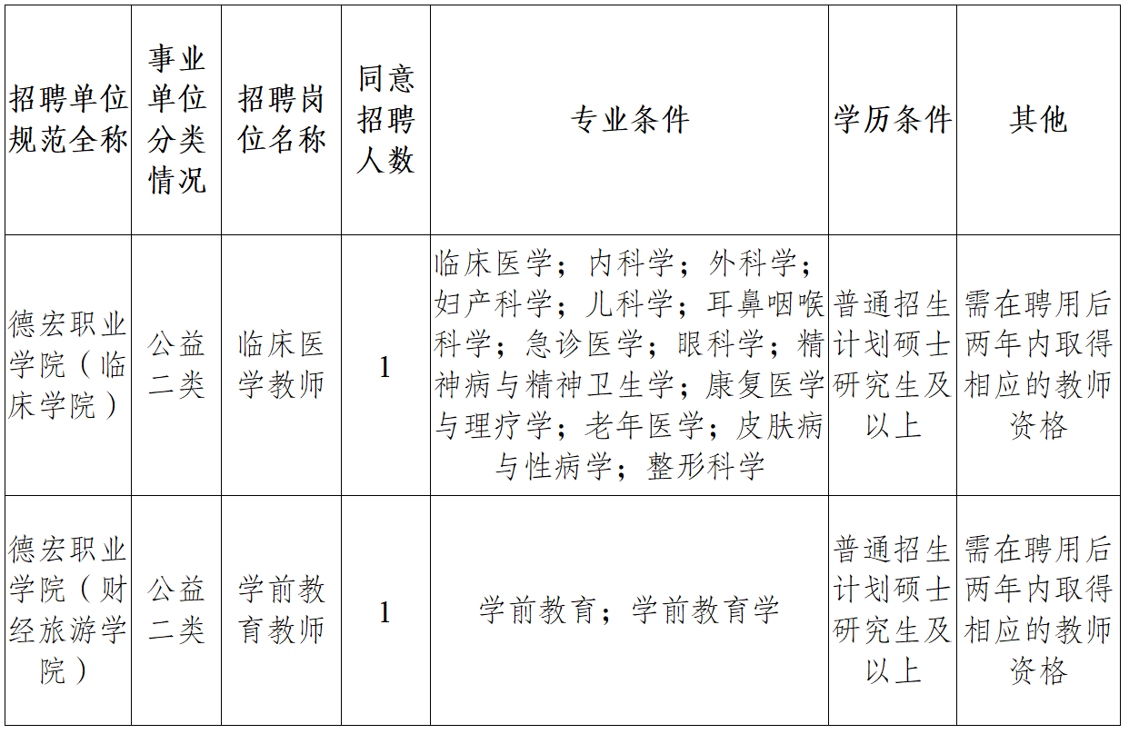](https://www.yndhvc.com/uploadfile/2021/0730/20210730045049673.png)